## Prelim Pages

Version Control /Approval etc

## Introduction

The spreadsheet contains macro’s that are intended by design to serve generation of new data, processing and manipulation of data between the master and the test tool.

## Action Initiation

Actions are initiated by the user clicking on one of the buttons in the ribbon. The buttons, through the XML file added to Excel, contains the link between the button and the project ribbon module subroutine.

## Button XML

Figure 1 below is a partial of the XML in custom UI.xml. Features to note are:

* Tab is the SAP tab in the ribbon (value in label)
* Buttons are organised into groups on the ribbon
* Button sets the ribbon button properties

The connection between XML data and the routine it calls is the **onAction** value, shown in Figure 2 below, which is set to “Btn_Export_QTP”.

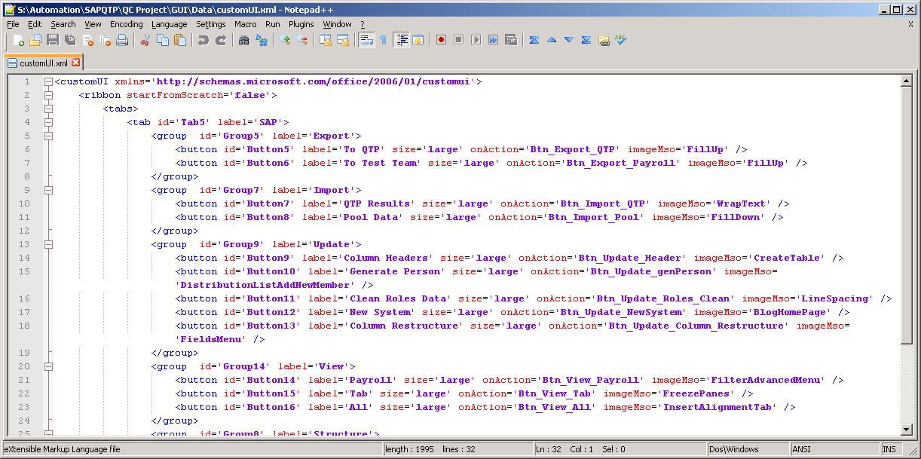

Figure – customUI XML

Maintainers need to be aware of this link when updating the ribbon xml file.

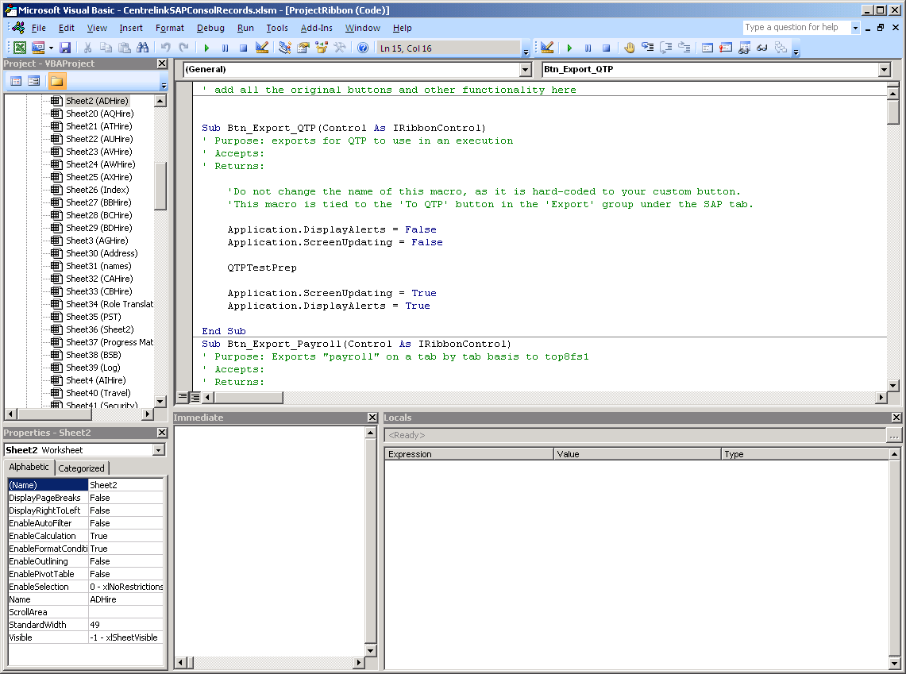

Figure – VB Project

## Export

Export has 3 paths that are exercised based on the ribbon button clicked and via additional data collected. The paths are:

* Complete sheet-wise copy (Raw to testers)
* User Friendly sheet-wise copy (Testers Format)
* Complete sheet-wise to sheet copy (to Test Tool)

Each path utilises common code to perform the actual data transfer.

## Import

Import has two paths exercised based on the ribbon button clicked:

* Complete sheet to sheet-wise copy (Import from Test Results).
* Structure Generator (regardless of need to generate).

As per export, there is a common import function used by all import from other workbooks.

## Update Functions

There are several update functions; consisting of:

* Column Restructure
* Fill Missing Data
* Column Headers
* Clean Roles Data
* New System

Fill Missing Data and New System utilise a common functionality to update the data tables for a new system. In both cases, they work on the visible data set.

Column Restructure exports all the data sets and opens a purpose built form with all the required code. On accepting the changes this also uses an import function to restore the data sets.

Clean roles is a quick method to clean up the roles data by removing or replacing old codes that arose early in the consolidation project. Future iterations there may be old data still held by a tester and there is a possibility that the invalid roles can pollute the data purity.

Column Headers is a quick way to make an update after the user does minor changes to ACHire header.

...oooOOOooo...